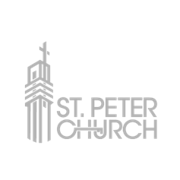
Marriage Preparation Checklist:

- Fill out the Wedding Intake Form at your first meeting with the priest.

- Review “Marriage Forms and Guidelines” at www.cospq.org/sacraments/marriage

- Take Foccus Test (Pre-marital inventory). You will receive an email inviting you to take this online test approximately 6 months before your wedding.

- Marriage Preparation - Pre Cana or Evenings for the Engaged. You will be contacted by Gina Bergman, Director of Religious Education and Sacramental Preparation, 6 months prior to your wedding.
g.bergman@cospq.org, 217-214-0182.

- Contact Monica Scholz, Parish Music Director (regardless if you have another musician) at least 3 months before your wedding.
m.scholz@cospq.org, 217-214-0131

- For questions about existing décor in the church and items that can be utilized for your wedding, contact Ronda Wand, Art & Environment coordinator, at least one month in advance, 217-653-7756.

- Wedding fee and honorariums paid by the night of the rehearsal.
- Marriage license - bring to rehearsal.

